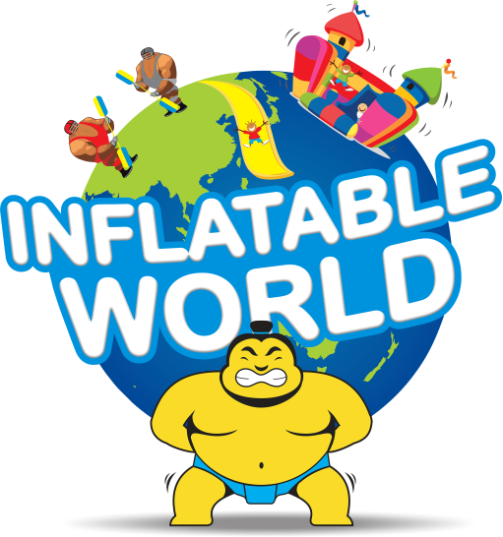

SCHOOL & SOCIAL GROUP FUNCTIONS & VENUE HIRE

2 hours exclusive use @ $12 each
Minimum charge $1,200

CAFE / BAR PRICES
NakedEspresso Cafe menu $4.00
Assorted beers $6.00
Spirits $7.00
Wine & Champagne (small bottle) $7.50
Pre mix Vodka varieties $7.50

----------------------------------------------------------------------------------------------------------------------------------------------------------------------------------------------------
Bookings & more info on 9568 7000 / 0417 107 001 or at inflatableworldoakleigh.com.au

